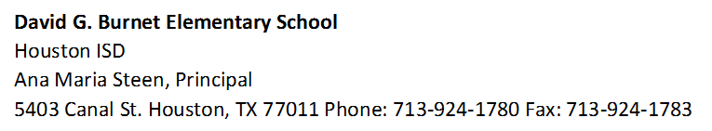
Title I Annual Meeting
Fall 1aMeeting Minutes
November 8, 2023

- Ms. Campos began the meeting by introducing herself and Mr. Sanchez, our parent engagement representative. Parents then introduced themselves by stating their name and grade level of their child/children. Ms. Campos then introduced our new Wraparound specialist – Mr. Olvera. He reintroduces himself and gives some of his background as well as his current role and responsibilities. He explains the SAF forms and makes himself available to provide parents with support. He gives further information on ways he can provide support and how they can contact him. Parents were glad to hear we have a Wraparound specialist again and two of them stayed behind after the meeting to sign up for a meeting with Mr. Olvera.
- Ms. Campos then provides a GT flyer for parents who are interested in registering their child/children in K-1,3-5 to get tested. Ms. Campos explains that this year the district tested all 2nd grade students for GT instead of K and 5th grade students like in previous years. The parents ask further questions – type of test and length. Ms. Campos answers their questions and displays the application online for them to view. She explains there’s no paper application and we can support them complete their application in the office. She gives them Ms. Arroyo (assistant principal) information as she’s the one who will receive the applications and schedule testing.
- Ms. Campos then explains the different resources available on Clever and explains that students have access to this platform at home as well. She provides QR codes for parents to try logging in and offers support with downloading the application on their devices. Parents who attended the meeting received their child’s QR code, but Ms. Campos explained all parents would receive their child’s QR code by the end of the week. Parents began to download the application and browsing through the different resources such as Raz Kids and Zearn.
- Ms. Campos closes the meeting by reminding them of the importance of attendance everyday and reminding them of upcoming events (provides monthly calendar). Parents don’t have further questions – only 1 stayed behind for extra support with Clever.

